**Level 1: PC Tower Case**

**Outline**

Learn about the internals of a standard PC case by examining physical samples and selecting and labeling images found on-line. Gain deeper knowledge by researching and reporting on specific components.

**Questions**

1. Find one (or more) images that clearly show the internals of a PC Tower Case.   
   (i.e. Google images using keywords “PC Case Internals”)
2. Clearly label the following components (using arrows) on your image of the PC case internals:
   1. Motherboard
   2. Power Supply
   3. Hard Disk Drive
   4. Optical Disk Drive (e.g.DVD)
   5. USB Expansion Ports
   6. Monitor Port
   7. Audio Ports
   8. Ethernet Port
   9. Cooling Fan

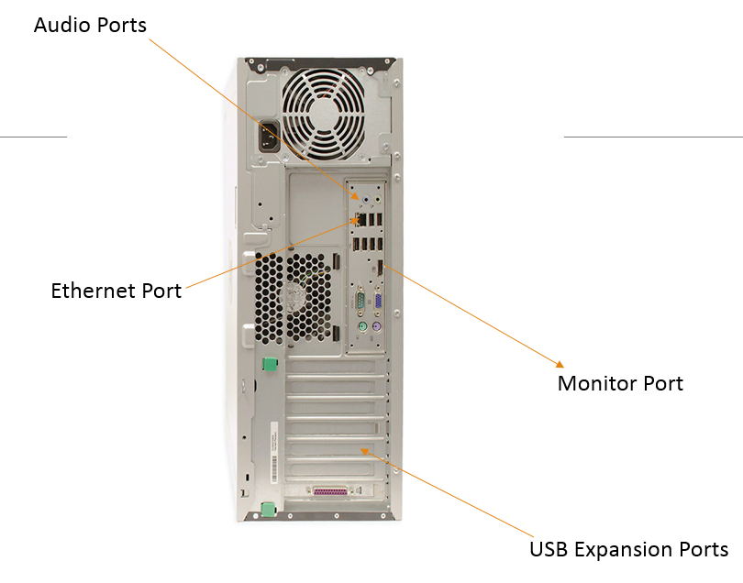

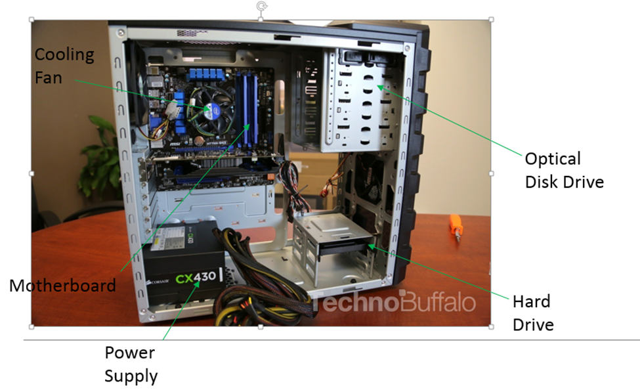

1. Research more in-depth about “Motherboards”. Make notes on the following:
   1. What different versions are currently available (speed and capacity)
   2. How the component has changed since the 1980’s

~ IBM – International Business Machines – developed the first motherboards as we know them today in 1981

~ It was called a Planar, which contained the computer’s CPU – central processing unit and the RAM, or the random access memory

~ ICs (single Integrated Circuits), proficient of sustaining low-speed peripherals such as mouse, keyboards, serial ports, etc., were integrated on the motherboards in the 1990s

~ During the late 1990s, they started to include full series of audio, video, networking as well as storage functions on them. Advanced end functions for graphic cards and 3D gaming were in addition incorporated later

~ Today, in the 21st century, the motherboard has really evolved into containing everything all computers need to be very powerful, from graphics, to terabytes of memory and much more. With today’s computers, user can also add different cards such as sound cards and or graphic cards to further enhance the motherboard

1. Research more in-depth about “Hard Disk Drives”. Make notes on the following:
   1. What different versions are currently available (speed and capacity)
   2. How the component has changed since the 1980’s  
      ~ The IBM 350 Disk File was developed under the code-name RAMAC by an IBM San Jose team led by Reynold Johnson. It was announced in 1956 with the then new IBM 305 RAMAC computer

~ It had a total capacity of 3.75 megabytes

~ In 1961, Bryant Computer Products introduced its 4000 series disk drives. Access times were from 50 to 205 milliseconds (ms). The drive's total capacity, depending on the number of platters installed, was up to 205,377,600 bytes (205 MB)

~ The first disk drive to use removable media was the IBM 1311 drive. It was introduced in 1962 using the IBM 1316 disk pack to store two million characters

~ In the 1980s, hard disk drives for personal computers (PCs) were initially a rare and very expensive optional feature; systems typically had only the less expensive floppy disk drives or even cassette tape drives as both secondary storage and transport media. However by the late '80s, hard disk drives were standard on all but the cheapest PC and floppy disks were used almost solely as transport media

~ HDDs continued to get smaller with the introduction of the 3.5-inch form factor in the middle of the decade Rodime 1983 and the 2.5-inch form factor PrairieTek 1988

~ Industry participants continued to decline in total to 15 in 1999. Unit volume and industry revenue monotonically increased during the 1990s to 174 million units and $26 billion

~ In 2001 the HDD industry experienced its first ever decline in units and revenue. The number of industry participants decreased to 6 in 2009 and 3 in 2013. Unit production peaked in 2010 at about 650 million units and has been in a slow decline since then. Shipments in 2017 estimated at about 404 million units.

**Level 2: PC Motherboard**

**Outline**

Learn about the structure of a standard PC motherboard by examining physical samples and selecting and labeling images found on-line. Gain deeper knowledge by researching and reporting on specific components.

**Questions**

1. Find one (or more) images that clearly show the layout of a PC Motherboard.   
   (i.e. Google images using keywords “PC Motherboard”)
2. Clearly label the following components (using arrows) on your image of the PC motherboard:
   1. CPU (and fan)
   2. RAM Memory
   3. Disk Drive Interface (IDE or SATA)
   4. GPU Graphics Processor (either on-board or Graphics Card)
   5. Sound Processor (either on-board or Sound Card)
   6. Wi-Fi / Ethernet Network Interface (either on-board or Graphics Card)

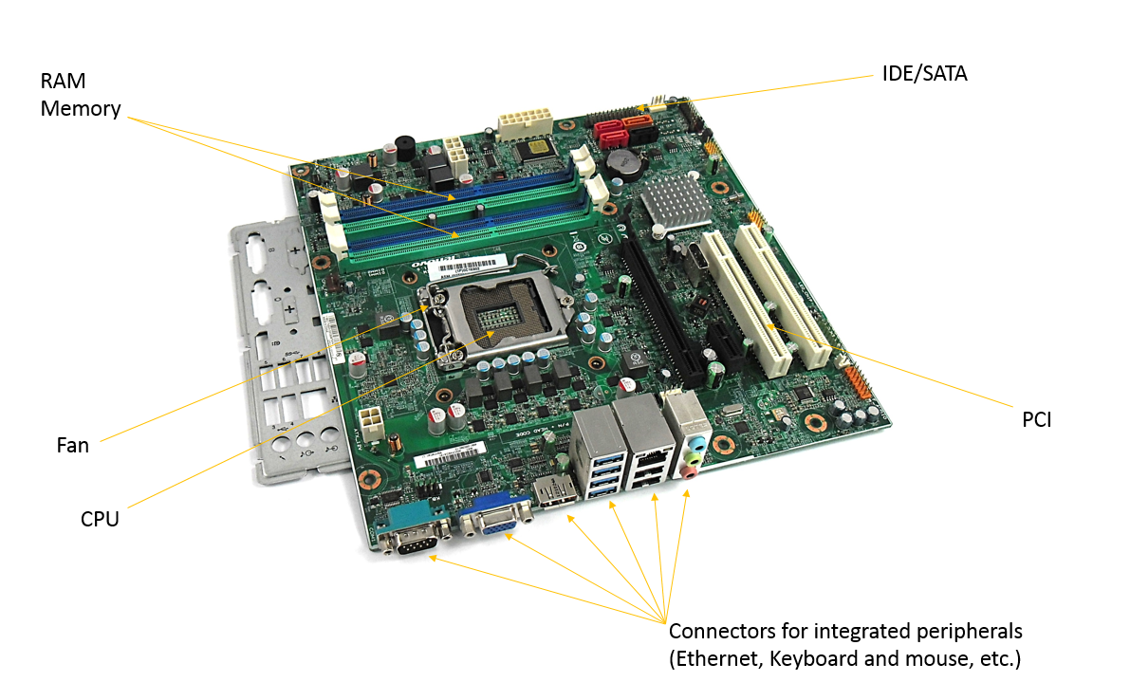

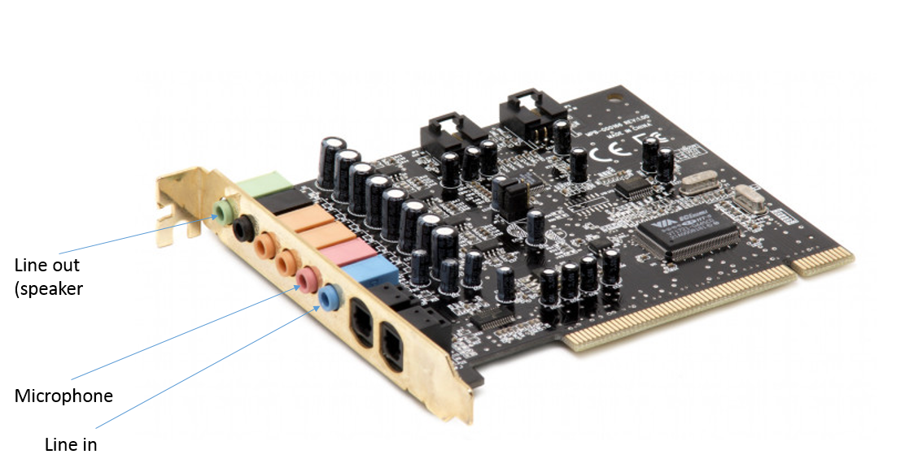

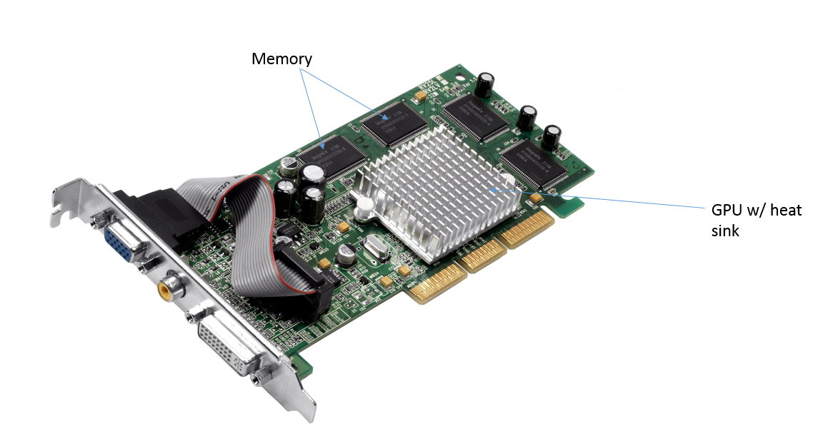

1. Research more in-depth about “CPU Processor Chip”. Make notes on the following:
   1. What different versions are currently available (speed and capacity
   2. How the component has changed since the 1980’s

~ The Intel 8088 was released on June 1, 1979

~ In 1979, The Motorola 68000, a 16/32-bit processor was released and was later chosen as the processor for the Apple Macintosh and Amiga computers

~ The Intel 80286 was introduced on February 1, 1982

~ The Intel 80286 was introduced on February 1, 1982. In 1985, Intel introduced the first 80386

~ In 1991, Intel introduced the Intel 486SX chip in April in efforts to help bring a lower-cost processor to the PC market selling for $258.00

~ Intel released the second generation of Intel Pentium processors on March 7, 1994. Intel introduced the Intel Pentium Pro in November 1995.

~ AMD introduced the K5 processor on March 27, 1996, with speeds of 75 MHz to 133 MHz and bus speeds of 50 MHz, 60 MHz, or 66 MHz. The K5 was the first processor developed completely in-house by AMD

~ AMD announced a new branding scheme on October 9, 2001. Instead of identifying processors by their clock speed, the AMD Athlon XP processors will bear monikers of 1500+, 1600+, 1700+, 1800+, 1900+, 2000+, etc. Each higher model number will represent a higher clock speed

~ The past 10ish years in terms of CPU processor chips have been filled with AMD and Intel making new processors, nothing super ground-breaking

1. Research more in-depth about “RAM Memory”. Make notes on the following:
   1. What different versions are currently available (speed and capacity)
   2. How the component has changed since the 1980’s

~ The first form of RAM came about in 1947 with the use of the Williams tube. It utilized a cathode ray tube (CRT) and data was stored on the face of the CRT as electrically charged spots

~ The second widely used form of RAM was magnetic-core memory, invented in 1947. Magnetic-core memory works through the use of tiny metal rings and wires connecting to each ring. One bit of data could be stored per ring and accessed at any time

~ RAM as we know it today, as solid-state memory, was first invented in 1968

~ Since 2006, "solid-state drives" (based on flash memory) with capacities exceeding 256 gigabytes and performance far exceeding traditional disks have become available. This development has started to blur the definition between traditional random-access memory and "disks", dramatically reducing the difference in performance

**Level 3: Peripheral Devices**

**Outline**

Learn about how peripheral devices are connected to the back side of a typical PC tower case. Examine physical samples, select and labeling images found on-line and gain deeper knowledge by researching and reporting on specific components.

**Questions**

1. Find one (or more) images that clearly show the layout of the back of a typical PC tower case.   
   (i.e. Google images using keywords “Back Of PC Tower”)
2. Clearly label the following components (using arrows) on your image of the back of a typical PC tower case:
   1. Power cord and power switch
   2. Monitor Interface (VGA or DVI or HDMI)
   3. Mouse Interface (USB or PS/2)
   4. Keyboard Interface (USB or PS/2)
   5. USB Ports
   6. Audio Inputs / Outputs
   7. Ethernet Interface

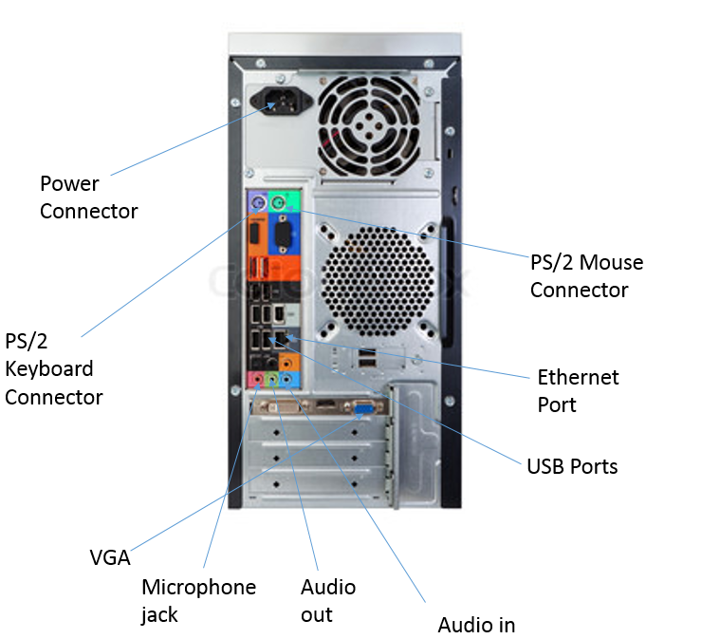

1. Research more in-depth about “Monitor Technology”. Make notes on the following:
   1. What different versions are currently available (e.g. VGA / DVI, Flat Panel Technology))
   2. How the component has changed since the 1980’s (e.g. Display Resolution, Technology)

~ One of the earliest electronic displays was the CRT (cathode ray tube), which was first demonstrated in 1897 and made commercially available in 1922. The earliest CRTs were monochrome

~ The first commercially available colour CRT was produced in 1954

~ They were the most popular display technology used in television sets and computer monitors for over half a century; it wasn't until the 2000s that LCD's began to replace them

~One of the more recent and better display technology is LCD (liquid crystal display); they don't consume a lot of electricity and their compact size

~ There are also LED monitors (light-emitting diodes); they're flat paneled displays that display things quite well, but they're quite expensive

1. Research more in-depth about “External Portable Storage”. Make notes on the following:
   1. Floppy Disks
   2. CD-ROM / DVD / Recordable CD/DVD
   3. USB Memory Drives
   4. Compact Flash Memory
   5. Cloud Based Storage  
      ~ A floppy disk is a type of disk storage composed of a disk of thin and flexible magnetic storage medium. They're read and written by a floppy disk drive. They were very popular from the 1970s up to the early 2000s, but computers now are barely manufactured with floppy disk drives  
      ~ A CD-Rom is an optical compact disc which contains data. Computers read CD-Roms, but cannot write to them, because they're not writable or eraseable. During the 1990s, they were used to distribute software and data for computers and video game consoles  
      ~ USB flash drives are often used for storage, data back-up and transfer of computer files. Compared with floppy disks or CDs, they are smaller, faster, have significantly more capacity, and are more durable due to a lack of moving parts  
      ~ CompactFlash (CF) is a flash memory mass storage device used mainly in portable electronic devices. The format was specified and the devices were first manufactured by SanDisk in 1994. CompactFlash became the most successful of the early memory card formats, surpassing Miniature Card and SmartMedia  
      ~ Cloud storage is a model of computer data storage in which the digital data is stored in logical pools. The physical storage spans multiple servers (sometimes in multiple locations), and the physical environment is typically owned and managed by a hosting company